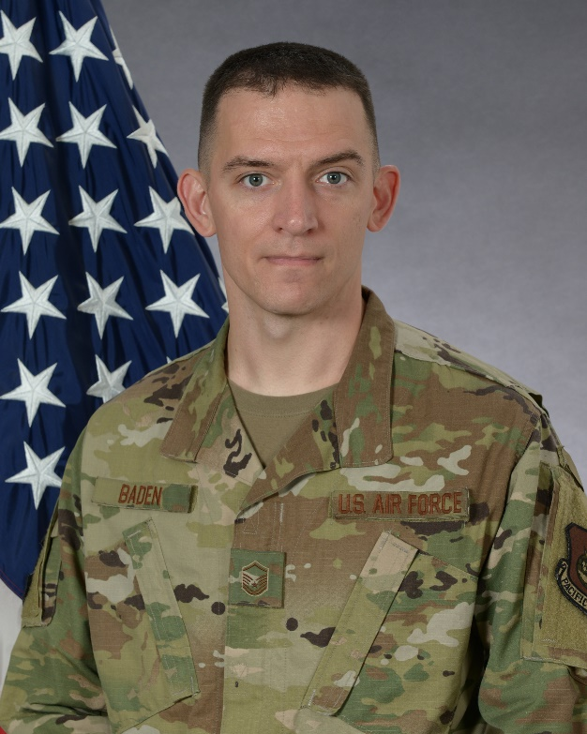
MASTER SGT. BRANDON BADEN

Master Sgt. Brandon Baden is in his first season with the F-16 Viper Demonstration Team. As the Superintendent, his responsibilities include supervising the maintenance of the team's three F-16s, individual training, manage the team’s budget and organizing all aircraft logistics, lodging, and travel arrangements throughout the world.
Master Sgt. Baden entered active military service in September 2003 as an Aerospace Propulsion Technician. He is a graduate of Osbourn Park High School in Manassas, VA. He has been stationed at locations in Texas, South Carolina and the Republic of Korea. Prior to his selection to the team, he served as the Specialist Section Chief for the 51st Aircraft Maintenance Squadron at Osan Air Base, South Korea.
EDUCATION
2008 Airmen Leadership School, Dyess AFB, TX.
2011 Noncommissioned Officer Academy, McGhee-Tyson ANGB, Tenn.
ASSIGNMENTS
1. September 2003–October 2003, Basic Military Training, Lackland AFB, Texas
2. October 2003–March 2004, Student, 361st Training Squadron, Sheppard AFB, Texas
3. March 2004–May 2008, Aerospace Propulsion Technician, 7th Component Maintenance Squadron, Dyess AFB, Texas.
4. May 2008–January 2010, Aerospace Propulsion Craftsman, 7th Component Maintenance Squadron, Dyess AFB, Texas.
5. January 2010-June 2010, Aerospace Propulsion Craftsman, 20th Component Maintenance Squadron, Shaw AFB S.C.
6. June 2010–July 2012, Quality Assurance Inspector, 20th Maintenance Group, Shaw AFB, S.C.
7. July 2012–November 2013, Jet Engine Test Facility NCOIC 20th Component Maintenance Squadron, Shaw AFB S.C.
8. November 2013–November 2015, Specialist Expediter, 20th Aircraft Maintenance Squadron Shaw AFB S.C.
9. November 2015–July 2016, JEIM Production Supervisor, 20th Component Maintenance Squadron Shaw AFB, S.C.
10.July 2016-July 2017, JEIM Section Chief, 20th Component Maintenance Squadron, Shaw AFB, S.C.
11.July 2017-November 2018, Test Cell Section Chief, 20th Component Maintenance Squadron, Shaw AFB S.C.
12. November 2018–October 2019, Specialist Section Chief, 51st Aircraft Maintenance Squadron, Osan Air Base, ROK
13. November 2019–Present, Superintendent, F-16 Viper Demonstration Team, Shaw AFB, S.C.
MAJOR AWARDS AND DECORATIONS
Meritorious Service Medal
Air Force Commendation Medal with one oak leaf cluster
Air Force Achievement Medal
Korea Defense Service Medal
DATES OF PROMOTION
Airman Basic September 16, 2003
Airman 1st Class October 31, 2003
Senior Airman February 28, 2006
Staff Sergeant May 1, 2008
Technical Sergeant June 1, 2012
Master Sergeant January 1, 2017

