UGH…I Have NO Motivation To Write This
Five Minutes to Thrive: 26-30 Nov 18

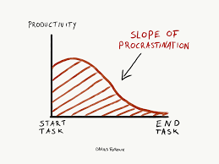
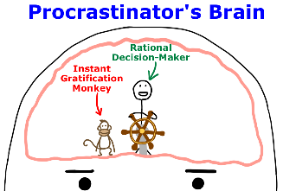
There’s, like, 50 things on my To-Do list, and honestly this one is just not that high of a priority. In fact, there’s a bunch of other things I need to do that are much more important or that will be really quick to check off the list (easy kills). Actually, I think part of my problem concentrating right now is this messy desk, so let me straighten up real quick…that helped my mind unclutter. Better go outside the building now and check my phone in case I have any messages, or in case my friends tagged me in any dank memes. Now I’ll call my mom! Whoops, looks like it’s time for lunch already, I think I’ll go check out this new restaurant off base. Okay, time to focus…oh wow I got a bunch of emails, better respond to these and make sure there’s nothing urgent. Looks like there are a few taskers here that are high-vis, and though they’re not due for a while I should probably take care of these, first. Are my bills paid this month?? I should probably check…okay, good to go. I need a break, I wonder how my coworkers are doing. Wow, those guys are crazy! I can’t wait to share that joke about the duck and the marmoset. I wonder what other cool jokes I can find on the interwebs…oh, that reminds me, I need to find a cool picture for this 5M2T! I guess maybe I should first figure out what I’m going to write about…but maybe if I find a funny graphic I can center the email on that. Oh sweet, here’s a listicle on what my favorite 90’s TV stars have been up to…and here’s another article…and another one…and another one…and I wonder what this person’s wikipedia page says? Huh, I didn’t know they were in that movie, let me see if I can find the trailer. Oooh maybe I can see this flick sometime this weekend, lemme look up some movie times. Should probably get on BookFace to see what everyone else is up to…WHAT I CAN’T BELIEVE MY EX IS DATING HIM?!?! Okay, okay, I’ve only got about an hour left to finish this up…and I’ve barely written anything! Time to get serious, I need some more coffee. Okay, now I’m going to research some popular psychology topics and see what jumps out at me. Oh wow, I remember that experiment! I can’t believe they conditioned Little Albert to fear the bunny. And that mention of Pavlov certainly rings a bell…maybe I can do another Freudian topic, like how he seemed to really like cigars or something…oh shoot, I’ve gotta send this out soon and I still have nothing! Okay, I’m just gonna type up a few sentences about…motivation? Rationalization? Or…Procrastination!
- Plan out the big tasks. Separate the larger jobs that will take a lot of sustained effort into their many subcomponent tasks, then start working on those one-by-one. Checklists are great for this and can be really motivating!
- Eliminate distractions. Close any unrelated browser tabs, get in a conducive environment, turn off the TV, and put away the smartphone. Don’t risk becoming distracted.
- Conduct your work slow and steady. One of the most prolific authors I know only writes 15 minutes a day—but religiously. Plan to make even just a little progress, every day. Sometimes it’ll be difficult, but other times you’ll hit the flow and do even more. Be a turtle, not a hare!
- DO IT. Tell yourself there’s no other choice, and that you MUST take action on it right now.
For questions, contact Dr. Jerry Walker, 363 ISRW/ART, @ jerry.walker.16.ctr@us.af.mil or 757-764-9316

