**Looking Back to Look Forward**

**Five Minutes to Thrive: 24-28 Dec 18**

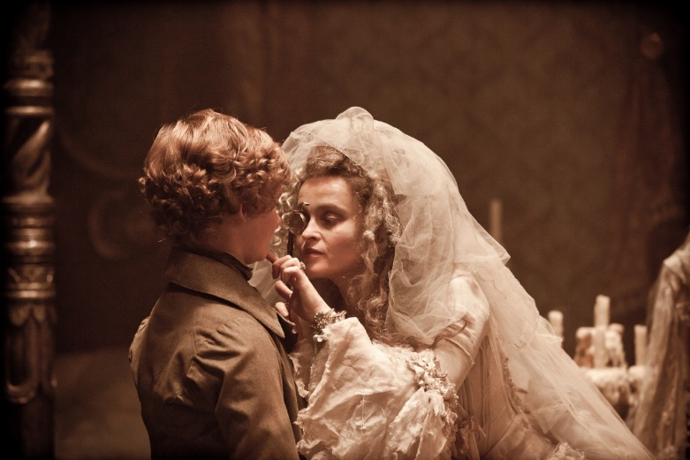Many of you probably read Charles Dickens’ masterpiece *Great Expectations* in middle school or high school, or perhaps you’ve watched one of the several (1946, 1998, 2012) film adaptations of this tragic story over the years. As a brief refresher, the story focuses on the life and trials of an orphan named Pip, who from the support of a wealthy benefactor Miss Havisham, becomes a successful “gentleman” and falls in love with her adopted daughter, Estella, whom he attempts to court over the course of the novel. The reader learns that Miss Havisham, having been jilted by her former lover, has raised Estella to be cold and aloof, teaching her only how to break mens’ hearts (something at which she is cruelly successful), particularly when it comes to Pip.

While the story focuses predominantly on Pip and his pining after Estella, I always felt the “true” message Sir Charles was expressing laid with Miss Havisham. She became so fixated on the singular tragedy of her life that she never let it go; she wore her wedding dress every single day, she kept the clocks in her mansion stopped at the time of her wedding, she lived as a recluse for the remainder of her life, and she dedicated her existence to passing on the hurt and heartbreak she felt to innocent others. By living in the past, she created and sustained a hateful attitude, a depressogenic mindset, and a set of skewed beliefs regarding the nature of humanity. These things kept her from ever being able to realize happiness, hope, or a truly fulfilling or socially-connected life.

While it’s important for us to use the lessons from our past to guide our present and future, *living* in the past—either through our past positive accomplishments or our tragedies and traumas—prevents us from living in the future. That is why I would encourage you to take some time at the end of this calendar year to take stock of the past 12 months and see what you have learned about your past experiences; then, allow them to settle in the past and adjust your lens to focus on what the coming year might bring. You can use your past to inform your future, but make sure to do so in a manner which will allow you to overcome your challenges and build on your successes!

- **Celebrate your accomplishments.** Identify the victories you had this year, and make a list of all those things about which you’re proud. It feels great to be reminded of your achievements!

- **Acknowledge your challenges.** Most likely, not everything went exactly your way this year. Dissect what went wrong, how you can make some personal changes to remediate the situation, and what you can do to prevent these things from becoming obstacles in the future.

- **Set “Great Expectations” for 2019.** The new year starts off where this one ends. Treat it like a blank slate, and ask yourself what you reasonably hope to accomplish in one years’ time. Leave the past in the past, and focus on where you want to be; SMART goals are your friend!

*For questions, contact Dr. Jerry Walker, 363 ISRW/ART, @ jerry.walker.16.ctr@us.af.mil* or 757-764-9316