**MAXIMIZING A NON-LABOR DAY**

**SG Weekly: 04-08 Sep 17**

The American holiday of “Labor Day” owes its origin to the heads of several labor unions in New York, who in 1882 devised a day of non-labor to commemorate the social and economic contributions of (primarily industrial) workers to our country’s prosperity. Several states soon followed suit, creating their own annual holiday between 1887 and 1894. However, it was not until after 23 states had officially recognized a type of non-labor day that President Grover Cleveland signed “Labor’s Holiday” into federal law as the first Monday of each September.

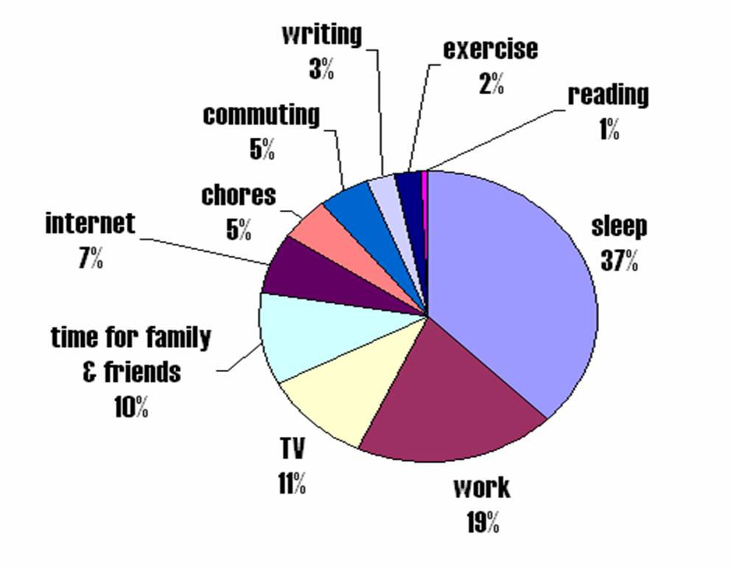While parades and post-parade rabble-rousing were standard fare in the holiday’s heyday, no official guidance was suggested as to how workers should utilize this non-labor day; the only stipulation was that there should be no “work.” If this concept sounds familiar, you might recall the ***work/life balance*** trope. A misnomer on its own—as work is a part of life and therefore inseparable—the concept implies a discrete division of diametrically-opposed desires: exertion vs. enjoyment, career vs. family, money-making vs. money-spending. Balance is of course essential to satisfy each of these requirements, as it is depicted as a zero-sum game; too much of one comes at the expense of the other. But sometimes circumstances prohibit you from managing the balance you desire; working late or on weekends, recalls or exercises, and TDYs/deployments come to mind. So when some life aspects of your pie chart begin to infringe upon other areas, what can you do?

- **Compartmentalize (mentally) but join (behaviorally).** If you find yourself thinking about work whilst at home and home whilst at work, visualize an artificial barrier separating the two major spheres of your life; once you cross the barrier, you switch into “home” mode or “work” mode. However, sometimes our lives don’t always fit in neat partitions; in these cases, try to combine areas to maximize your use of time (i.e. exercise with family members, listen to an audiobook during your daily commute, catch up with friends while doing housework, etc.).

- **Find a hobby.** We all need something to do for fun outside of our daily responsibilities. Explore various hobbies, learn a new skill, or plan a new adventure to take you a little outside of your comfort zone. Or maybe there’s a particular hobby you’ve been neglecting lately…?

- **Ditch the electronics.** Scrolling through social media feeds and browsing the internet tends to be mindless, “filler” activity; put down the computer/phone and find something active to do. You might be surprised how you—all of the sudden—have more time on your hands.

- **Schedule time for nothing.** Well, not *literally* nothing. But something that isn’t necessarily goal-directed. Give yourself some downtime to relax and to reflect on the day or the week. Some of us need alone time, some people prefer to meditate, and others just like to be out in nature; whatever your “nothing” is, try to arrange for a little of it each week—it’s important!

*For questions, contact Dr. Jerry Walker, 363d ISRW Psychologist, @ jerry.walker.14@us.af.mil* or 757-764-9316